#include <iostream>
using namespace std;
template<class T>
class A
{
public:
T num1 = 5;
T num2 = 6;
void add()
{
cout<<"Add of num1 and num2 : "<<num1+num2<<endl;
}
};
int main()
{
A<int>d;
d.add();
return 0;
}
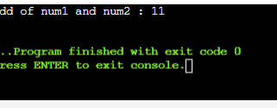
#include <iostream>
using namespace std;
template<class T1,class T2>
class A
{
T1 a;
T2 b;
public:
A(T1 x,T2 y)
{
a = x;
b = y;

}
void display()
{
cout<<"Values of a and b are : "<<a<<" ,"<<b<<endl;
}
};
int main()
{
A<int,float>d(5,6.5);
d.display();
return 0;
}
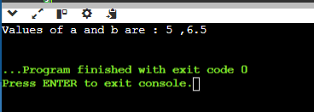
#include <iostream>
using namespace std;
template <class T>
class Smartpointer{
T *p;
public:
Smartpointer(T *ptr = NULL)
{
p = ptr;
}
~Smartpointer(){
delete(p);
}
T & operator * (){
return *p;
}
T * operator -> (){
return p;
}
};
int main()
{
Smartpointer<int> p(new int());
*p = 26;
cout<<"value is : "<< *p;
return 0;
}
Output:
